**Developers Assumptions:**

* Server API have only 10 results currently, if object with same keys will increase on server then app will start showing those items on list.
* Currently server do not support cache (server header have ‘no cache’) but code is implemented to handle that.
* I assume not to display any screen on click on item but just to show I put a toast on click on item.
* UI screenshots are attached.

**Portrait Screenshot.**

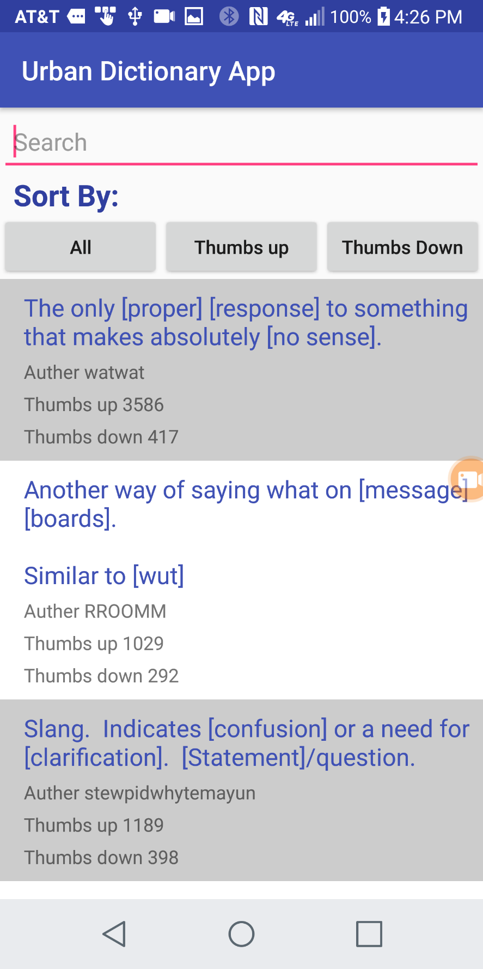

**Landscape mode:**

